KARNATAKA STATE OPEN UNIVERISTY
A project report entitled.

“Agromart”
A project Report submitted in partial fulfillment of the award of the degree of

MASTER OF COMPUTER APPLICATION

SUBMITTED BY
MOKSHITH P J
(Roll no: 08P232036900049)

UNDER THE GUIDANCE OF
Mrs. Suneetha, Msc, PGDHE

Associate Professor DoS&R in Computer Science KSOU, Mysuru-06

Department of Studies and Research in Computer Science Karnataka State Open University Manasagangothri Mysore-570006

Month-Year

KARNATAKA STATE OPEN UNIVERISTY
Certificate

This is to certify that the project work entitled “Agromart” is a Bonafide work carried out by B PRAMODKUMARA (Roll no:----) in partial fulfillment of a project in Master of Science in Computer Science, under Karnataka State Open University, Mysuru, during the year (mention the cycle and year like) January 2024. The project report has been approved as it satisfies the academic requirements in respect to project work prescribed for the Master of Science in Computer Science.

Under the guidance of Head of the department
Mrs. Suneetha Name
Associate Professor Chairperson
Department of Computer Science, Department of Computer Science,
KSOU KSOU
Mysuru-06 Mysuru-06

Examiners:

1………………………………

2………………………………

ACKNOWLEDGEMENT

We would like to sincerely thank all the people who were directly or indirectly involved in this project, without whose help the completion of this project would have been impossible.
We, thank whole heartedly our beloved principal of St. Philomena college, Puttur Rev. Dr. Antony Prakash Monterio for all this possible support by providing facilities to complete our project.
We thank Mr. Vinaychandra, HOD of Computer Science Department, for his valuable guidance and the extra effort that he is making every time to ensure correctness and perfection of what we are doing. We also remember all the lecturers who were more of a support to us than ever.
Our special thanks to all friends who have provided timely help and genuine feedback which helped us improve a lot.
Finally, we thank our parents, who financially supported us throughout the project and provided the support that we need throughout our life.

Place: Puttur By,

Date: 26-04-2026 Mokshith P J

Index

SL. NO | Table Of Content | Page No.
1 | Introduction  - Introduction of the System  - Project Title  - Category  - Overview  - Background  - Objectives of the System.  - Scope of the System.  - Structure of the System.  - System Architecture  - Software/Hardware used for the development.  - Software/Hardware required for the implementation
2. | Methodology
  - System Design
    - Functional Decomposition
- System Software Architecture
- System Technical Architecture
- System Hardware Architecture
- External Interfaces
    - Description of Programs
- Context Flow Diagram (CFD)
- Data Flow Diagrams (DFD)
  - Database Design.
    - Database Identification
    - Table Definition
    - ER Diagram
  - Detailed Design.
    - Modular decomposition of the System
    - Structure chart showing the hierarchy of modules.
    - Procedural details (Flow Chart) of components
3. | Analysis and Interpretation
  - Program Code Listing
  - User Interface (Screens and Reports)
 | Conclusion
  - Major findings
  - Conclusion
  - Limitations
  - Major findings
  - Suggestions / recommendations
  - Learning outcomes
  - Abbreviations and Acronyms
  - References

Chapter 1
INTRODUCTION

  - Introduction of the System.
Agromart is a web-based project that aims to help Farmers and Consumers. The main users of the system, the Farmers usually face a lot of problems in finding the good fertilizers, quality equipment’s or any other agriculture related items that will be helpful for them. The proposed system Agromart will solve the problem by developing a system that will provide all the agriculture-related information in one place.

    - Project Title
Agromart

    - Category
This application is a Client Defined Web Application. This application is developed with the help of PHP and MySQL Server.

    - Overview
The proposed framework is a Web based program that maintains a consolidated archive of all related information. The system allows you to quickly access the relevant details. Farmers can view and purchase the required tools or items from the website and also upload crops they farmed. Vendors who want to purchase crops from farmers bid for the crops.

    - Background
The Agromart project sounds like it could be an initiative related to agriculture and market development. Agriculture is a vital sector in many economies, providing food, raw materials, and employment opportunities. The ultimate goal would likely be to enhance the overall productivity, profitability, and resilience of the agricultural sector while improving the livelihoods of farmers and ensuring food security for the population.

  - Objectives of the System
- The Objective of the proposed system is to provide a platform where both users, Farmers and Consumers will get a system that will helpful for them regarding their respected problems.
- Farmers will get the items such as Fertilizers and any other Agriculture related items that are needed for them.
- They can also upload the Products that they are willing to sell.
- In other way Consumers will upload the items that they are selling and also will see the Products that are uploaded by Farmers and bid for them.

  - Importance and Scope of the System.
The main scope of the project is to provide a website for the betterment of Farmers. Now farmers facing problems like they are not getting the expected price for their crops and also they are not able to purchase the necessary products because of the mediators.

  - Structure of the System

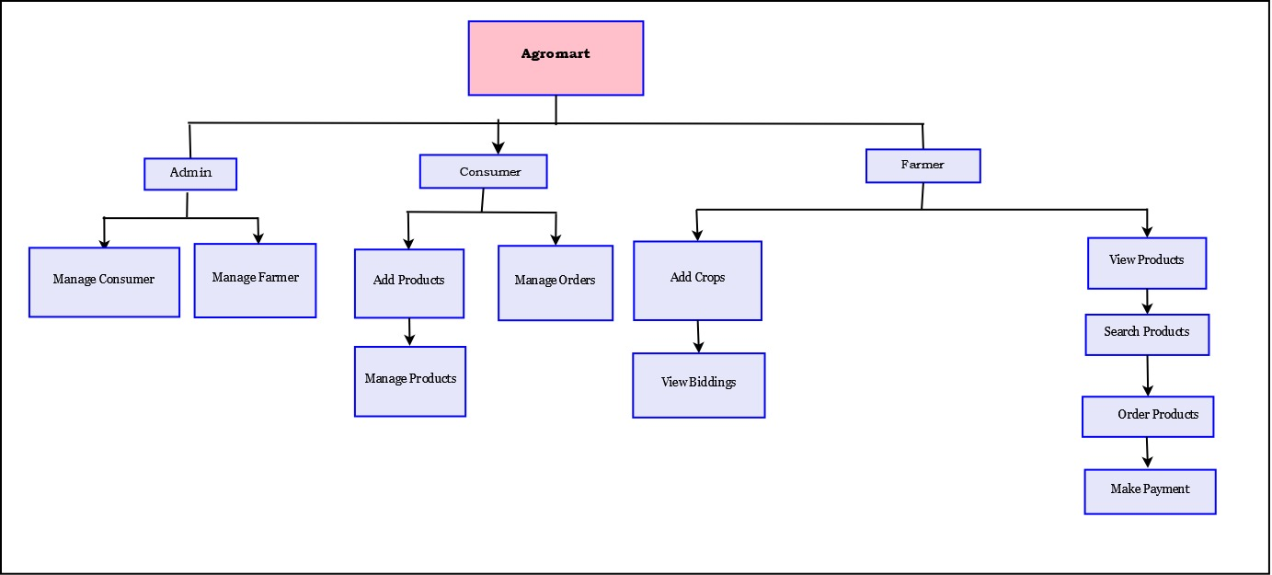
Figure 1.1 Structure of the System
The system Agromart contains three modules namely Admin, Consumer, farmer. The Admin manages the whole system. The consumer will add the services like adding products, Managing Orders, Managing Products. The Farmers can perform the activities like viewing Products, search for products, order Products and also make payment.

  - System Architecture
Software architecture is the set of structures needed to reason about a software system and the discipline of creating such structures and systems. Each structure comprises software elements, relations among them, and properties of both elements and relations.
The architecture of a software system is a metaphor, analogous to the architecture of a building. It functions as the blueprints for the system and the development project, which project management can later use to extrapolate the tasks necessary to be executed by the teams and people involved.

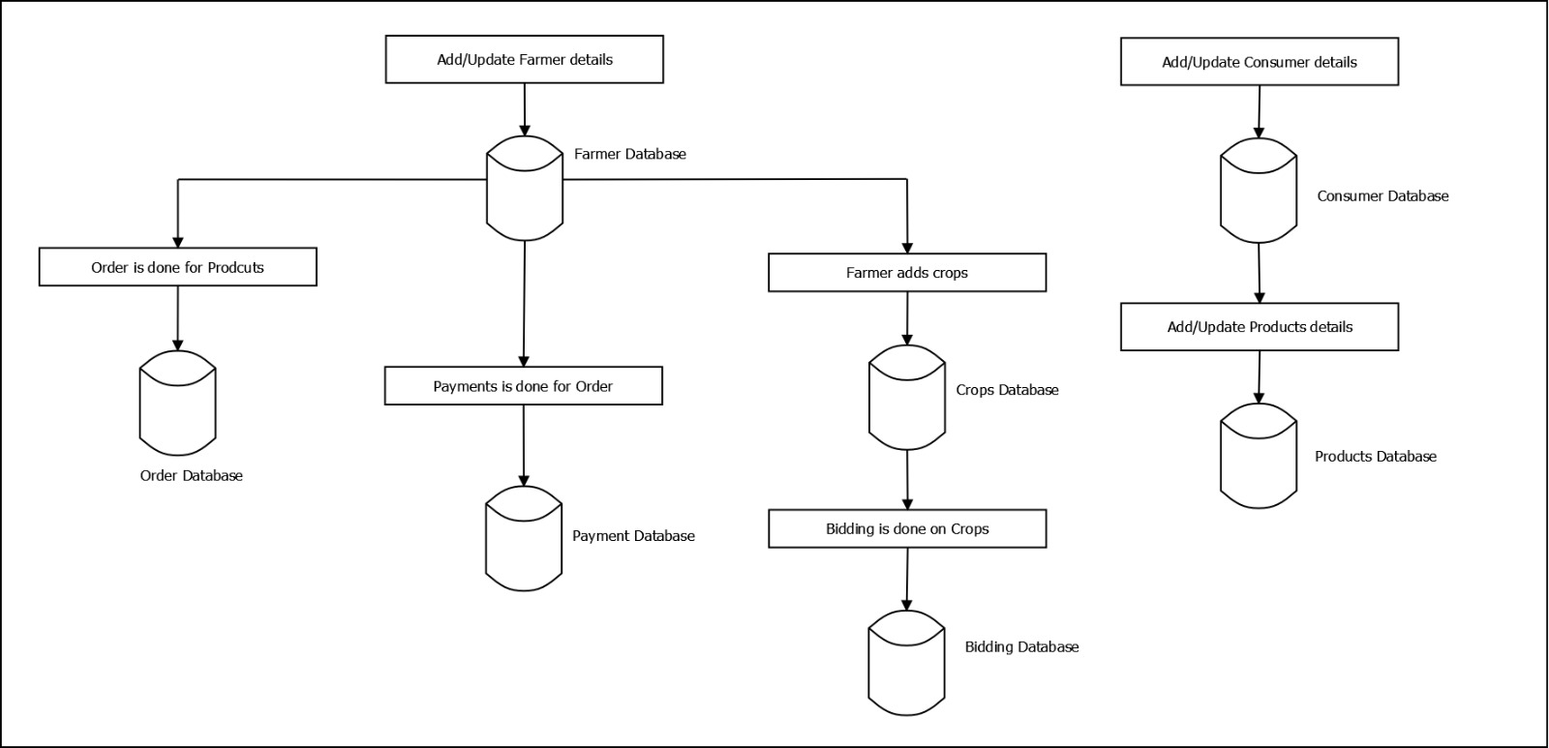
Figure 1.2 Structure of the System

  - Software/Hardware used for the development
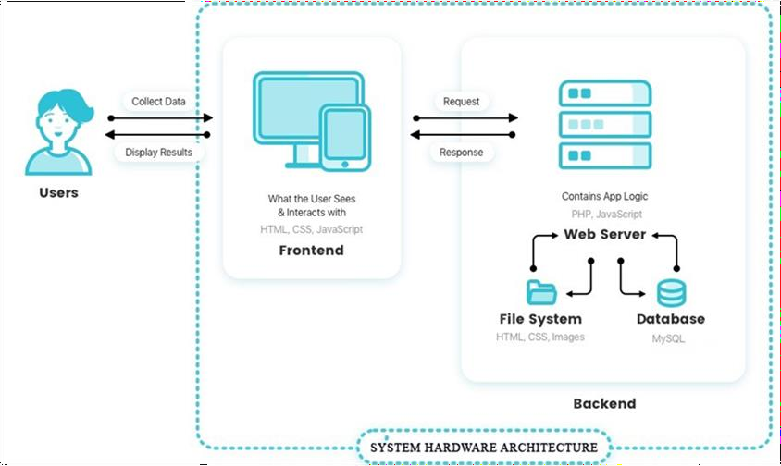
Figure 1.3 System Hardware Architecture
This Web Application is developed using free and open-source cross-platform web server solution stack for Windows WAMP. Front end application is developed using html, CSS, Javascript programming language. The data relieved by user interfaces are stored in the MySQL Server passing through Firewall. Apache Web Server will function as Web Server Software in the background. The application will be hosted on the Web using third-party service providers, where they implement Background Server for the backup purpose. Users may interact with the System using Workstation, Laptop or Smart phones.

  - Software/Hardware required for the implementation.
    - Software Requirements (for development)
IDE: Sublime Text 3
Server: Apache 2.4.39
Database: MySQL 5.7.26
Client Side: Chrome, Opera, Mozilla Firefox

    - Hardware Requirements (for development)
Operating System: Windows 7, Linux, Mac OS
RAM: 4GB or above
HDD: 500GB or above
Processor: 2.4 GHz or above

    - Software Requirements (for implementation)
IDE: Sublime Text 3
Server: Apache 2.4.39
Database: MySQL 5.7.26
Client Side: Chrome, Opera, Mozilla Firefox

    - Hardware Requirements (for implementation)
Operating System: Windows 7, Linux, Mac OS
RAM: 4GB or above
HDD: 500GB or above
Processor: 2.4 GHz or above

- HTML
Hyper Text Markup Language (HTML) is a simple markup system used to create hypertext documents that are portable from one platform to another. HTML documents are SGML documents with generic semantics that are appropriate for representing information from a wide range of applications. HTML markup can represent hypertext news, mail, documentation, and hypermedia; menus of options; database query results; simple structured documents with in-lined graphics; and hypertext views of existing bodies of information.HTML has been in use by the World-Wide Web (WWW) global information initiative since 1990. The HTML 3.0 specification provides a number of new features, and is broadly backwards compatible with HTML 2.0. It is defined as an application of International Standard ISO ISO8879:1986 Standard Generalized Markup Language (SGML).

- CSS
Cascading Style Sheets is a style sheet language used for describing the presentation of a document written in a markup language such as HTML.CSS is a cornerstone technology of the World Wide Web, alongside HTML and JavaScript. It is designed to enable the separation of presentation and content, including layout, colors, and fonts. It enables you to do this independent of the HTML that makes up each web page.

- PHP
PHP is a recursive acronym for "PHP: Hypertext Pre-processor". PHP is a server- side scripting language that is embedded in HTML. It is used to manage dynamic content, databases, session tracking, even build entire e-commerce sites. It is integrated with a number of popular databases, including MySQL, PostgreSQL, Oracle, Sybase, Informix, and Microsoft SQL Server. PHP is pleasingly zippy in its execution, especially when compiled as an Apache module on the Unix side. The MySQL server, once started, executes even very complex queries with huge result sets in record-setting time .PHP supports a large number of major protocols such as POP3, IMAP, and LDAP. PHP4 added support for Java and distributed object architectures (COM and CORBA), making n-tier development a possibility for the first time. PHP is forgiving: PHP language tries to be as forgiving as possible Syntax is C-Like. PHP performs system functions, i.e. from files on a system it can create, open, read, write, and close them. PHP can handle forms, i.e. gather data from files, save data to a file, through email you can send data, return data to the user. You add, delete, modify elements within your database through PHP.

- My SQL
MySQL is the world’s most widely used opensource Relational Database Management System (RDBMS) that runs as a server providing multi-user access to a number of databases. The MySQL development project has made it source code available under the terms of the GNU General Public License, as well as under a variety of proprietary agreements. MySQL was owned and sponsored by a single for profit firm, the Swedish company MySQL AB, now owned by Oracle Corporation. MySQL is a popular choice of database for use in web applications, and is a central development of the widely used LAMP opensource web application software stack. LAMP is an acronym for “Linux, Apache, MySQL, and Perl/PHP/Python” Free software-opensource projects that require a full feature database management system often use MySQL.

- Microsoft visual studio
Visual Studio Code is a lightweight but powerful source code editor which runs on your desktop and is available for Windows, macOS and Linux. It comes with built-in support for JavaScript, TypeScript and Node.js and has a rich ecosystem of extensions for other languages and runtimes (such as C++, C#, Java, Python, PHP, Go, .NET).

Chapter 2
METHODOLOGY

2.1. System Design
Software design is a process by which the software requirements are translated into presentation of software components, interfaces, and data necessary for the implementation phase. The System Design Document describes the system requirements, operating system environment, subsystem architecture, files and database design, input formats, output layouts, human-machine interfaces, detailed design, processing logic, and external interfaces.

2.1.1. Functional Decomposition

a. System Software Architecture


Figure 2.1 System software Architecture

In this System Software Architecture, we can find the working of the software. The user will be added by the admin. Then through logging in the consumer can add or update the product details, bid the crops. The farmer can add the crops, they can view the payment.

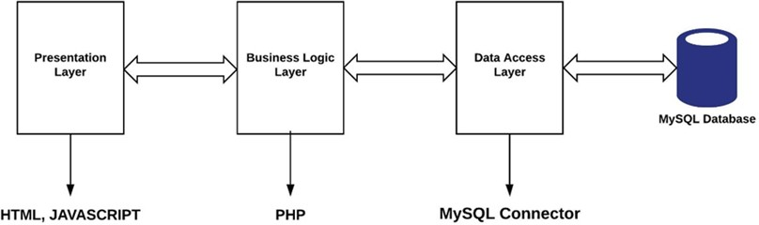
b. System Technical Architecture

Figure 2.2 System Technical Architecture

In system technical architecture we discuss the technologies used in each layer. In presentation layer html, and Javascript are used. In business logic layer PHP is used. In data access layer MYSQL connector is used. MYSQL database technology is used for storing data.

c. System Hardware Architecture


Figure 2.3 System Hardware Architecture

This Web Application is developed using free and open-source cross-platform web server solution stack for Windows WAMP. Front end application is developed using html, CSS, Javascript programming language. The data relieved by user interfaces are stored in the MySQL Server passing through Firewall. Apache Web Server will function as Web Server Software in the background. The application will be hosted on the Web using third-party service providers, where they implement Background Server for the backup purpose. Users may interact with the System using Workstation, Laptop or Smart phones.

d. External Interfaces
- Name of application: Agromart
- Owner of application:
- Details of interface: Login Panel, Register Panel, Consumer Panel, former Panel
- Type of interface: Graphical user interface

2.1.2. Description of Programs

a. Context Flow Diagram

Context Flow Diagram is a top level (also known as level0) data flow diagram. It contains only one process node that generalizes the functions of the entire system in relationship to external entities. In the context diagram the entire system is treated as a single process and all its inputs, outputs, sinks and sources are identified.

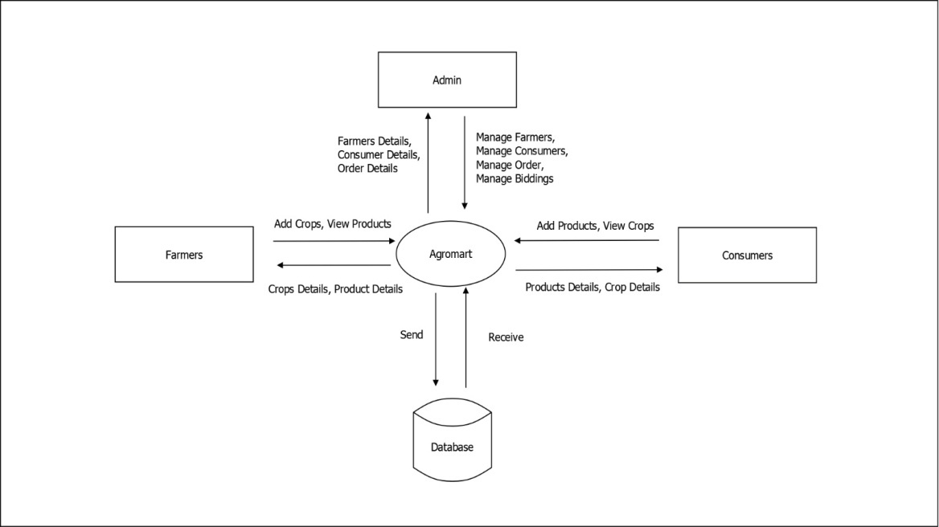
Figure 2.4 Context flow diagram

b. Data Flow Diagrams

Data Flow Diagram is a graphical representation of a system or a portion of the system. It consists of data flow, process, sources and sink and stores all the description through the use of easily understandable symbols. DFD is one of the most important modeling tools. It issued to model the system, components that interact with the system, and uses the data and information flows in the system. DFD shows the information moves through, and how it is modified by a series of transformations. It is a graphical representation that depicts information that moves from input to output. DFD is also known as bubble charts or Data Flows Graphs. DFD may be used to represent the system at any level of abstraction.

2.1.2.1. DFD (Level 1)

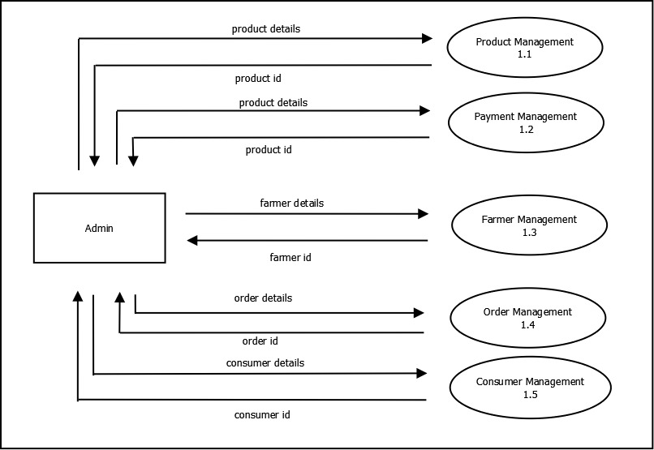

Figure 2.5 DFD Levels 1

2.1.2.2. DFD (Level 2)

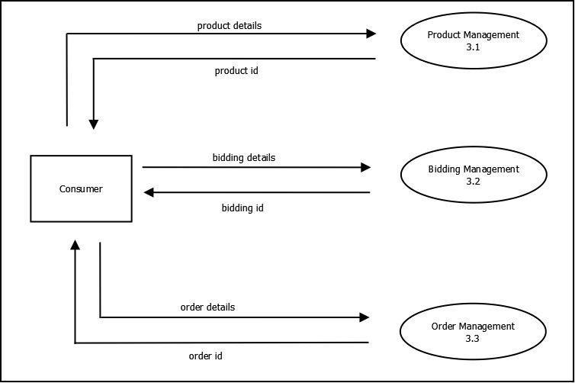

Figure 2.6 DFD Levels 2

2.1.1.3 DFD (Level 3)

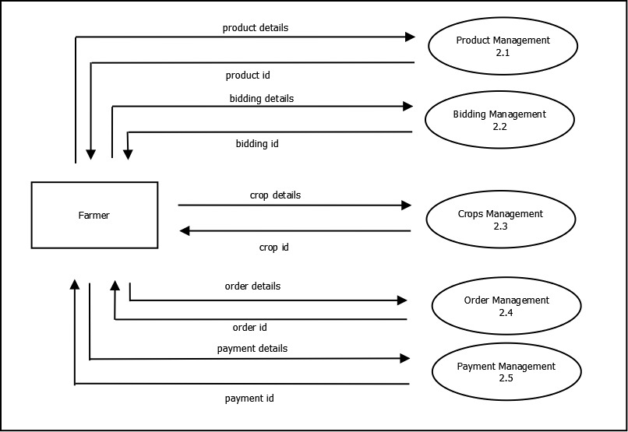

Figure 2.7 DFD Levels 3

2.2. Database Design
2.2.1. Database Identification
- To denote Database names, we use db.
- To name the tables we use small letters.
- To denote Primary key, we use pk.
- To denote foreign keys, we use fk.
- To name columns we use small letters

2.2.2. Table Definition

admin
Column | Type | Null | Description | Example
admin_id (Primary) | int(11) | No | To store Admin ID | 1001
admin_email | varchar(30) | No | To store Admin Email | admin@gmail.com
admin_username | varchar(30) | No | To store Admin Username | admin
admin_password | varchar(30) | No | To store Admin Password | admin

Indexes
Keyname | Type | Unique | Packed | Column | Cardinality | Collation | Null | Comment
PRIMARY | BTREE | Yes | No | admin_id | 1 | A | No

consumer
Column | Type | Null | Description | Example
consumer_id (Primary) | int(11) | No | To store Consumer ID | 2001
consumer_name | varchar(30) | No | To store Consumer Name | Ravi
consumer_email | varchar(30) | No | To store Consumer Email | ravi@gmail.com
consumer_contact_number | varchar(12) | No | To store Consumer Contact Number | 9876543210
consumer_address | text | No | To store Consumer Address | Bangalore – 560012
consumer_username | varchar(30) | No | To store Consumer Username | Admin
consumer_password | varchar(30) | No | To store Consumer Password | admin

Indexes
Keyname | Type | Unique | Packed | Column | Cardinality | Collation | Null | Comment
PRIMARY | BTREE | Yes | No | consumer_id | 1 | A | No

crops
Column | Type | Null | Description | Example
crop_id (Primary) | int(11) | No | To store Crop ID | 3001
crop_name | varchar(30) | No | To store Crop Name | Rice
crop_description | text | No | To store Crop Description | Sample
farmer_id | int(11) | No | To store Farmer ID | 2001
crop_initial_amount | int(11) | No | To store Initial Amount | 100
crop_amount | int(11) | Yes | To store Crop Price | 500
consumer_id | int(11) | Yes | To store Consumer ID | 6001
image_location | text | No | To store Crop Image location | ./images/1.jpg

Indexes
Keyname | Type | Unique | Packed | Column | Cardinality | Collation | Null | Comment
PRIMARY | BTREE | Yes | No | crop_id | 1 | A | No

farmers
Column | Type | Null | Description | Example
farmer_id (Primary) | int(11) | No | To store Farmer ID | 4005
farmer_name | varchar(30) | No | To store Farmer Name | Sample
farmer_email | varchar(30) | No | To store Farmer Email | sample@gmail.com
farmer_contact_number | varchar(12) | No | To store Farmer Contact Number | 9876543210
farmer_address | text | No | To store Farmer Address | Bangalore - 560012
farmer_username | varchar(30) | No | To store Farmer Username | Admin
farmer_password | varchar(30) | No | To store Farmer Password | admin

Indexes
Keyname | Type | Unique | Packed | Column | Cardinality | Collation | Null | Comment
PRIMARY | BTREE | Yes | No | farmer_id | 2 | A | No

feedbacks
Column | Type | Null | Description | Example
feedback_id (Primary) | int(11) | No | To store Feedback ID | 6415
feedback_from | varchar(30) | No | To store the person who sent Feedback | sample@gmail.com
feedback_to | varchar(30) | No | To store to whom the feedback has been sent | abc@gmail.com
feedback_subject | varchar(40) | No | To store Feedback Subject | Sample
feedback_message | text | No | To store Feedback Message | Sample

Indexes
Keyname | Type | Unique | Packed | Column | Cardinality | Collation | Null | Comment
PRIMARY | BTREE | Yes | No | feedback_id | 0 | A | No

notifications
Column | Type | Null | Description | Example
notification_id (Primary) | int(11) | No | To store Notification ID | 4152
notification_from_id | int(11) | No | To store Notification From User ID | 5412
notification_from | varchar(30) | No | To store Notification From Email ID | agfd@gmail.com
notification_to | varchar(30) | No | To store Notification to Email ID | jhf@gmail.com
notification_subject | varchar(30) | No | To store Notification Subject | Sample
notification_message | text | No | To store Notification Message | Sample

Indexes
Keyname | Type | Unique | Packed | Column | Cardinality | Collation | Null | Comment
PRIMARY | BTREE | Yes | No | notification_id | 2 | A | No

orders
Column | Type | Null | Description | Example
order_id (Primary) | int(11) | No | To store Order ID | 7458
farmer_id | int(11) | No | To store Farmer ID | 4125
product_id | int(11) | No | To store Product ID | 4444
invoice_number | varchar(30) | No | To store Invoice Number | KJGUF8741
amount | int(11) | No | To store Order amount | 4111
status | varchar(30) | No | To store Status of Order | ORDER PLACED
datetime | timestamp | No | To store datetime | 05-06-2024 12:54 PM

Indexes
Keyname | Type | Unique | Packed | Column | Cardinality | Collation | Null | Comment
PRIMARY | BTREE | Yes | No | order_id | 1 | A | No

payments
Column | Type | Null | Description | Example
payment_id (Primary) | int(11) | No | To store Payment ID | 5447
invoice_number | varchar(30) | No | To store Invoice Number | FUFI8745
status | varchar(30) | No | To store Payment Status | PAYMENT DONE
datetime | timestamp | No | To store datetime | 20-05-2024 01:65 PM
amount | int(11) | No | To store Amount | 5412

Indexes
Keyname | Type | Unique | Packed | Column | Cardinality | Collation | Null | Comment
PRIMARY | BTREE | Yes | No | payment_id | 1 | A | No

products
Column | Type | Null | Description | Example
product_id (Primary) | int(11) | No | To store Product ID | 5412
product_name | varchar(30) | No | To store Product Name | Sample
product_description | text | No | To store Product Description | Sample
product_amount | int(11) | No | To store Product Amount | 54112
consumer_id | int(11) | No | To store Consumer ID | 4125
image_location | text | No | To store Product Image Location | ./images/abv.jpg

Indexes
Keyname | Type | Unique | Packed | Column | Cardinality | Collation | Null | Comment
PRIMARY | BTREE | Yes | No | product_id | 1 | A | No

2.3.3. ER diagram

Entity relationship diagram is used in modern database software engineering to illustrate logical structure of database. It is a relational schema database modelling method used to model a system and approach. This approach is commonly used in database design. The diagram created using this method is called the E-R diagram.
An entity-relationship (ER) diagram is a specialized graphic that illustrates the relationships between entities in a database. ER diagrams often use symbols to represent three different types of information. Boxes are commonly used to represent entities. Diamonds are normally used to represent relationships and ovals are used to represent attributes.

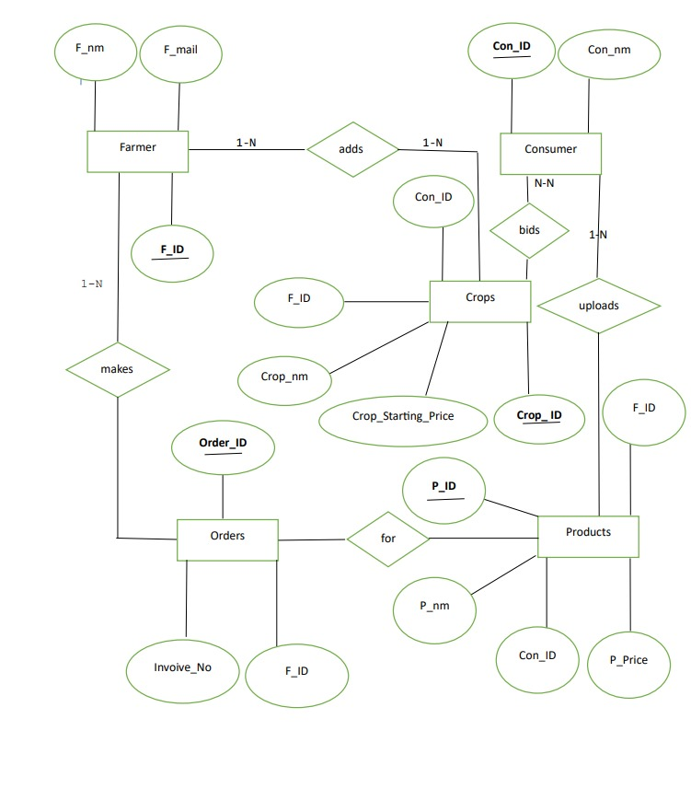

Figure 2.8 ER diagram

2.4. Detailed Design
2.4.1. Modular decomposition of the System
2.4.1.1. Functional Component 1: Admin
2.4.1.1.1. Design assumptions
This module is designed in such a way that it allows the administrator to use any of the options easily so that he can add, delete, modify or update any details. Admin module enables the admin to have control over the users and service providers.

2.4.1.2. Functional Component 1: Farmer
2.4.1.2.1. Design assumptions
This module is designed with an intention to allow Farmer to login, maintain their account, search for crops and update the product details. Farmer module is designed in such a way that it will be user friendly.

2.4.1.3. Functional Component 1: Consumer

2.4.1.3.1. Design assumptions

This module is designed to enable the consumer to create and maintain their account and input required details. This module will provide details of crops and the facility to login to their account. Consumer will be able to input or update data easily by filling in the given form.

2.4.2. Structure chart showing the hierarchy of modules

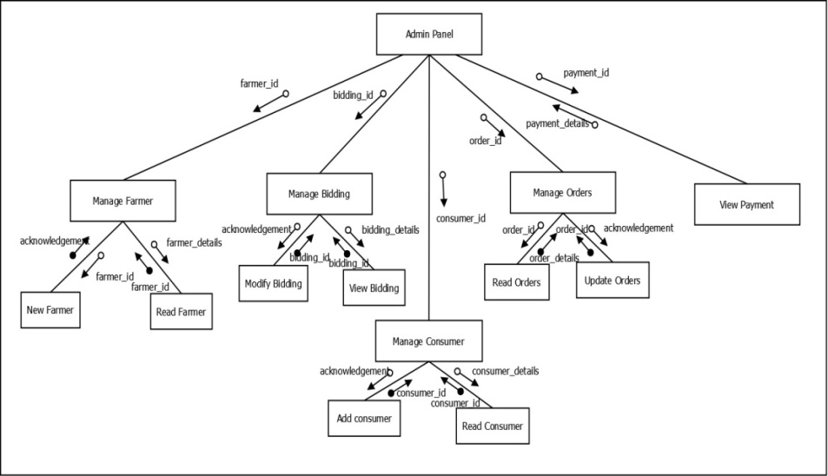

Figure 2.9 Structure chart of the Admin Login

2.4.2.1. Data Structures shared among modules
        - Farmer
        - Bidding
        - Orders
        - Payment

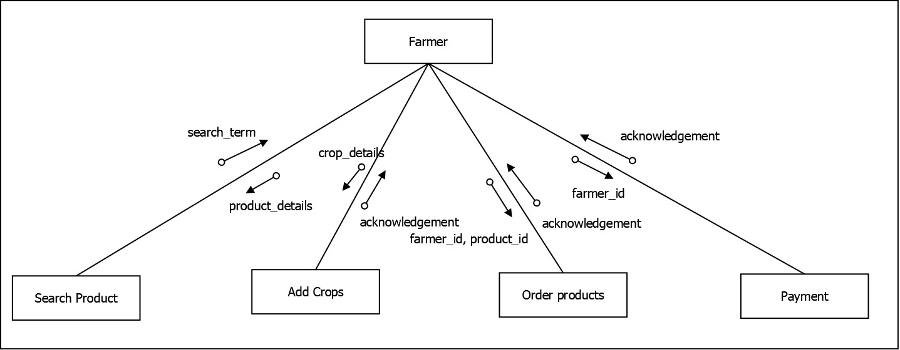
Figure 2.10 Structure chart of the Farmer

2.4.2.2. Data Structures shared among modules
        - Product
        - Crops
        - Payment

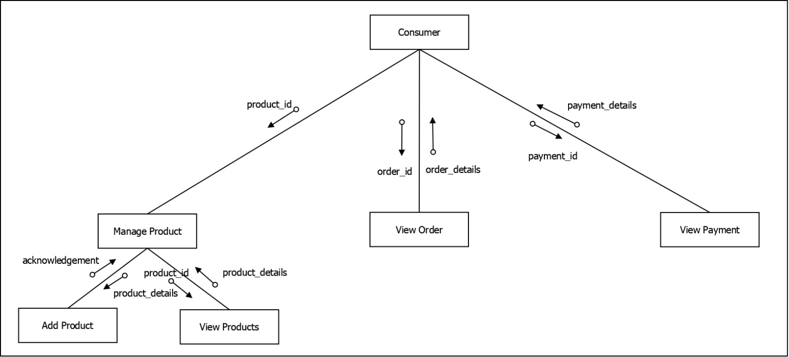
Figure 2.11 Structure chart of the consumer

2.4.2.3. Data Structures shared among modules
        - Product
        - Crops
        - Payment



Figure 2.11 Structure chart of the consumer

2.4.2.4. Data Structures shared among modules
        - Product
        - Order
        - Payment

2.4.3. Procedural details (Flow Chart) of components
Consumer
Inputs: cosumer_id, username
Procedural details (Flow Chart)
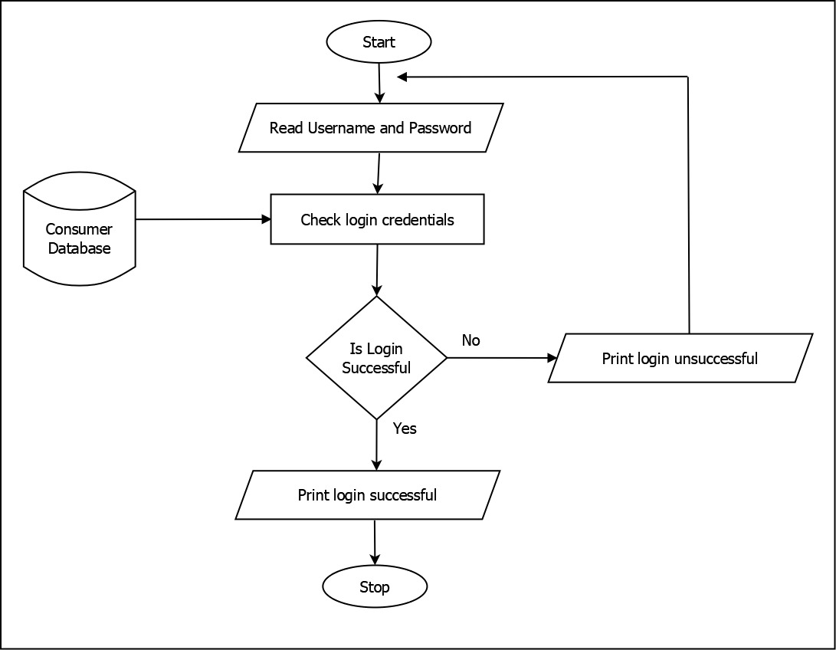
Figure 2.12 flow chart of the consumer

File I/O interfaces
The consumer is provided to add the details

Outputs: consumer details

View/add Consumer
Inputs: cosumer_id,view_consumer,add_consumer
Procedural details (Flow Chart)
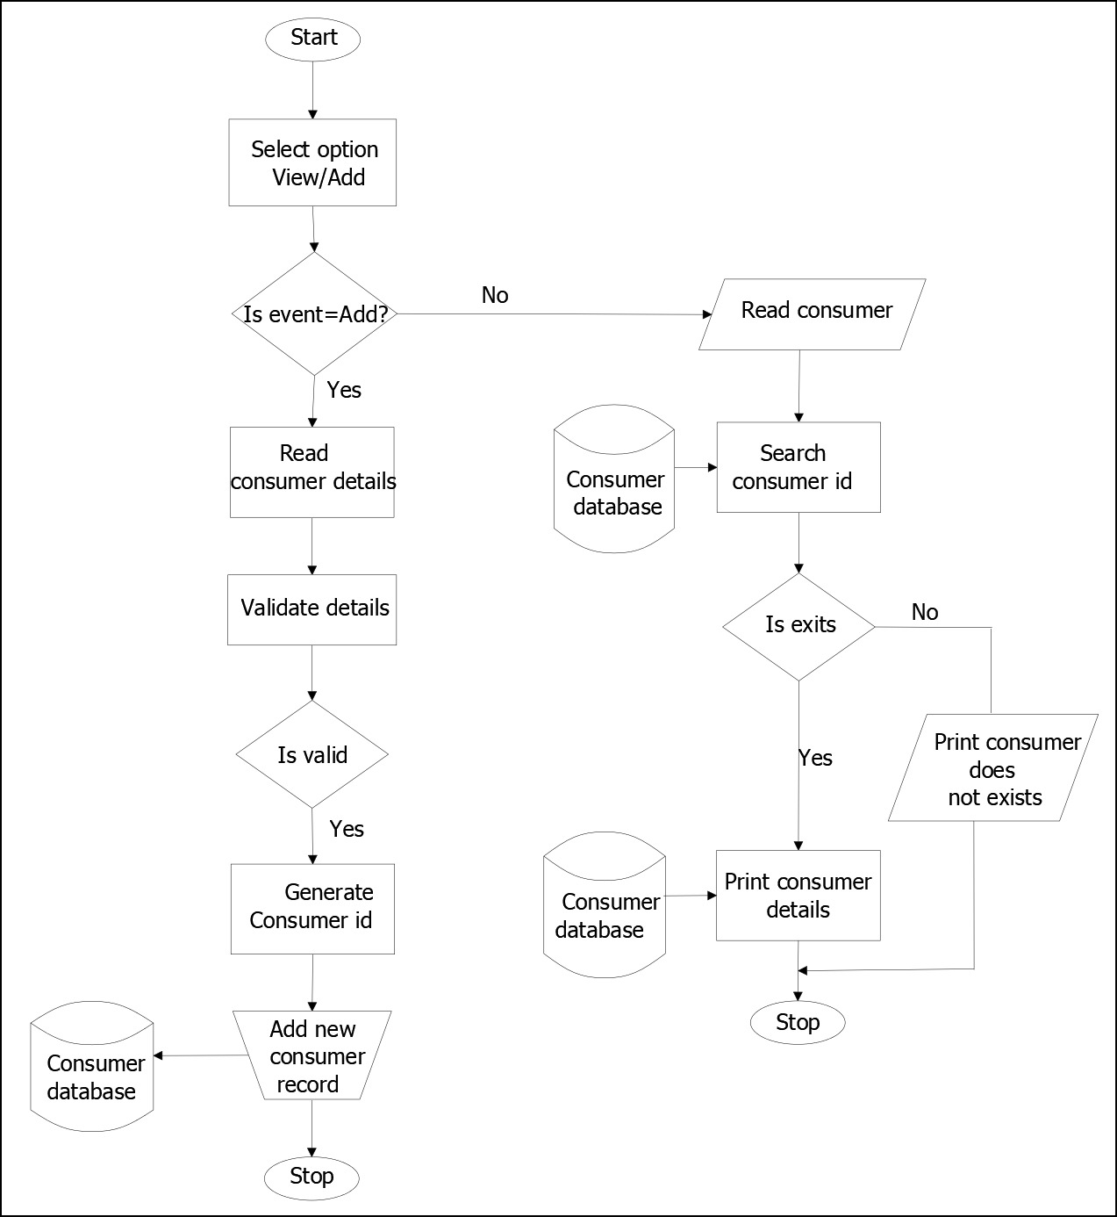
Figure 2.13 flow chart of the View/Add consumer
File I/O interfaces
The farmer can view the details of customers
Outputs: Adding of consumer, Viewing of consumer

View/Add Product
Inputs: product_id,view_product,add_product
Procedural details (Flow Chart)
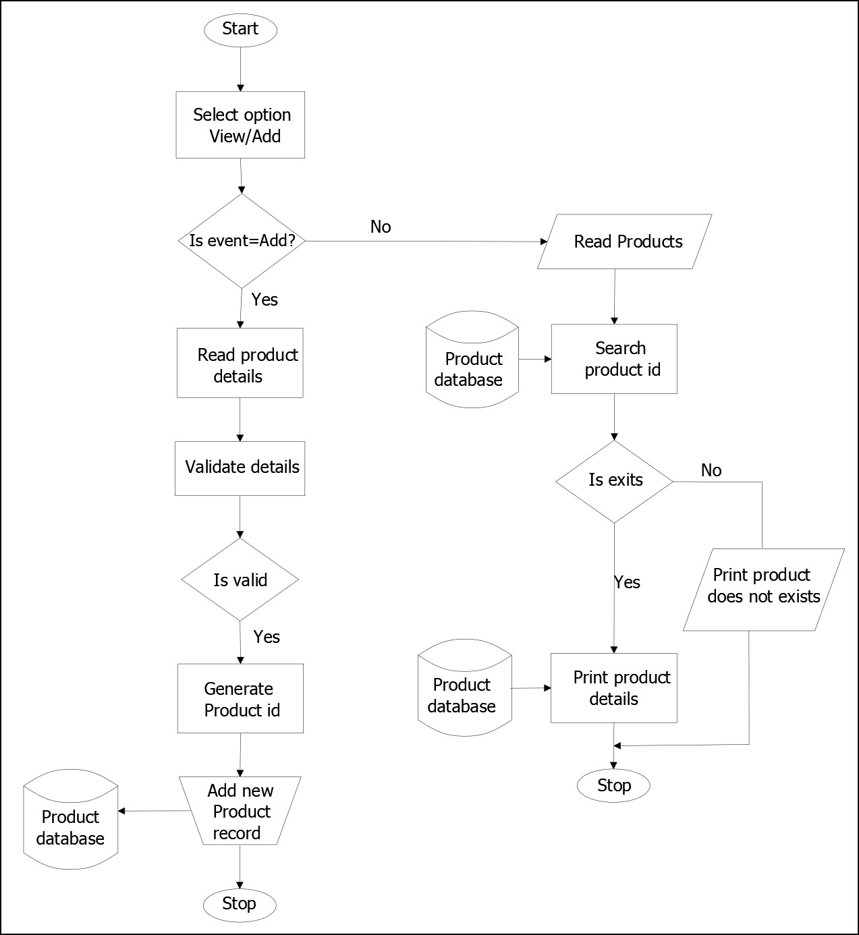
Figure 2.14 flow chart of the Product
File I/O interfaces
The farmer can add and view the product details
Outputs: add/view product details

View/Add Bidding
Inputs: bidding_id,view_bidding,add_bidding
Procedural details (Flow Chart)
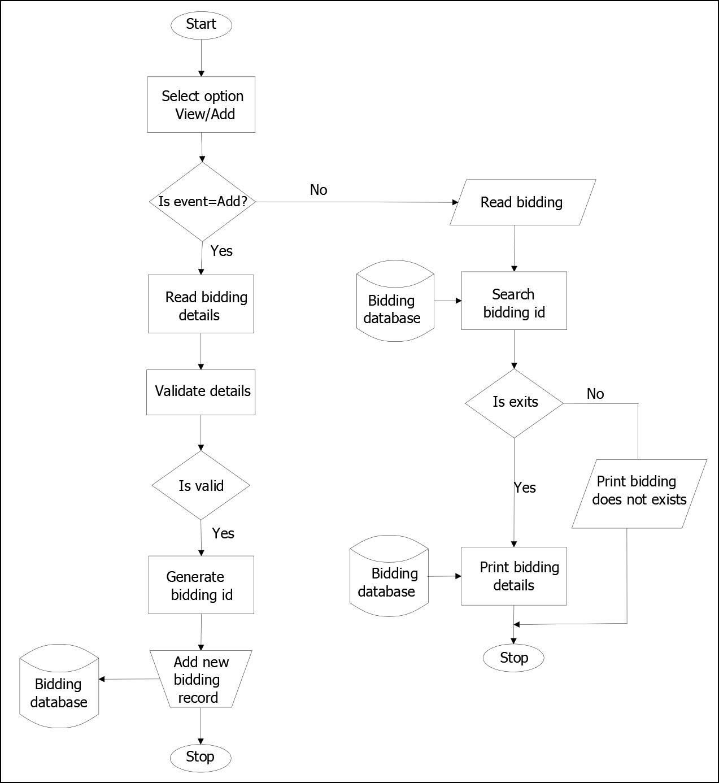
Figure 2.15 flow chart of the Bidding
File I/O interfaces
They can add and view the bidding and read the bidding done by the farmer
Outputs: add/view bidding details

Order
Inputs: farmer_id,product_id
Procedural details (Flow Chart)
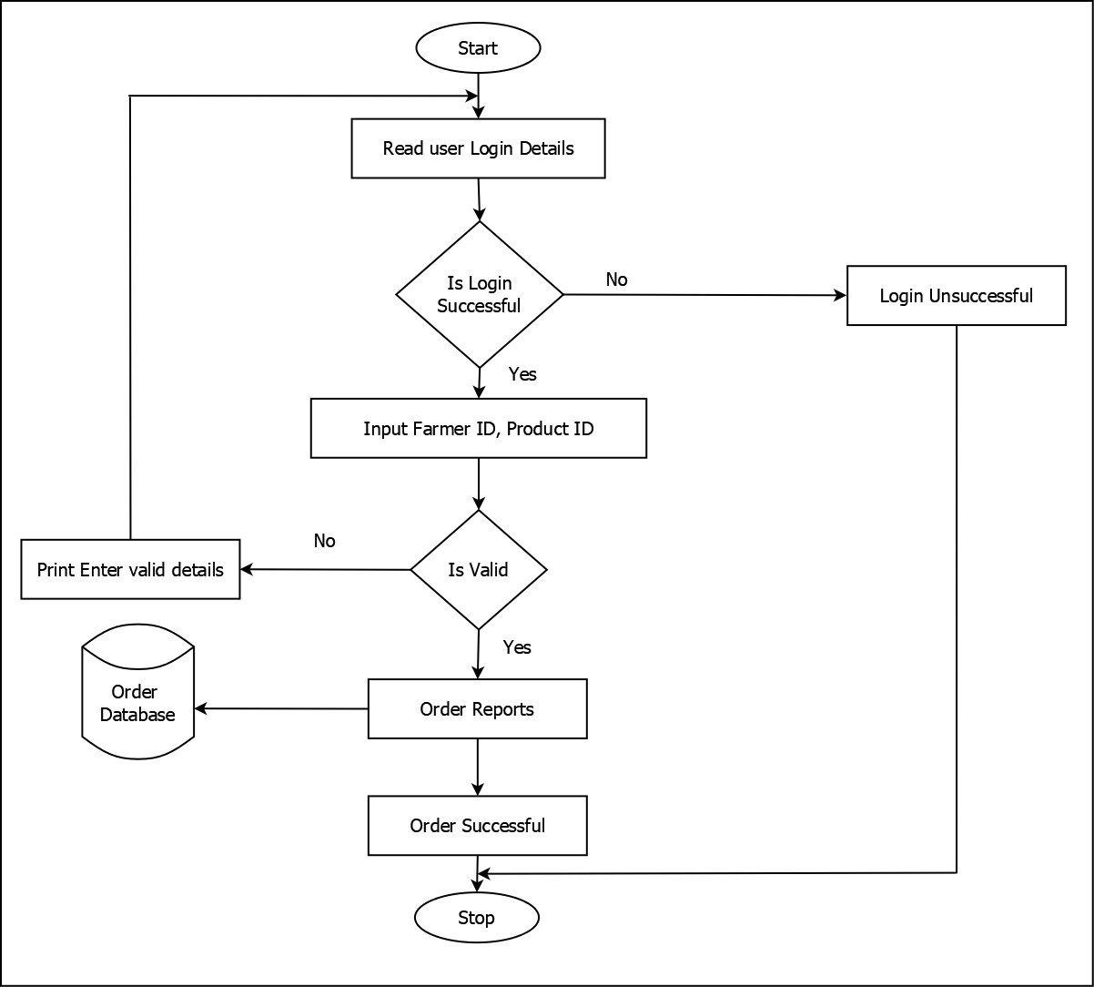
Figure 2.16 flow chart of the Order

File I/O interfaces
The user can log into the system, and they can view the order details
Output: order details

Order
Inputs: order_id
Procedural details (Flow Chart)
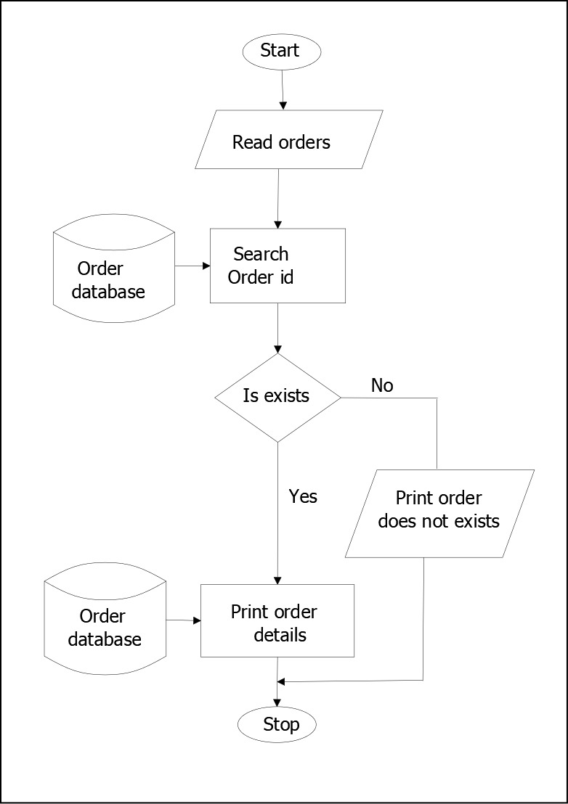
Figure 2.17 flow chart of the Search Order

File I/O interfaces
To input the order of crops
Output: order details

Product
Inputs: product_id
Procedural details (Flow Chart)
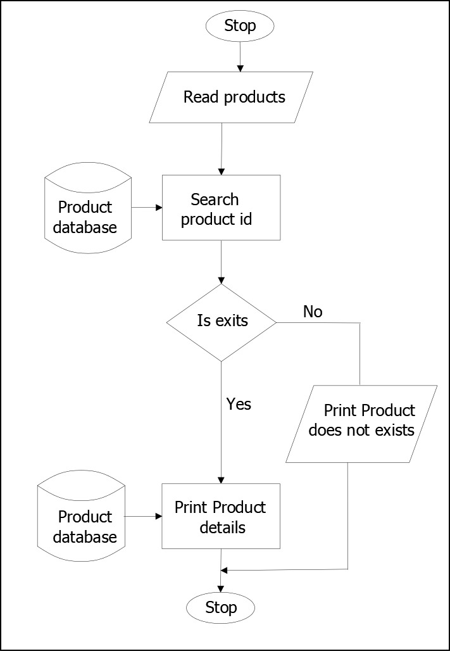
Figure 2.18 flow chart of the Product

File I/O interfaces
To input the order of crops
Outputs: product details

View/ Add Farmer
Inputs: famer_id,view_farmer, add_farmer
Procedural details (Flow Chart)
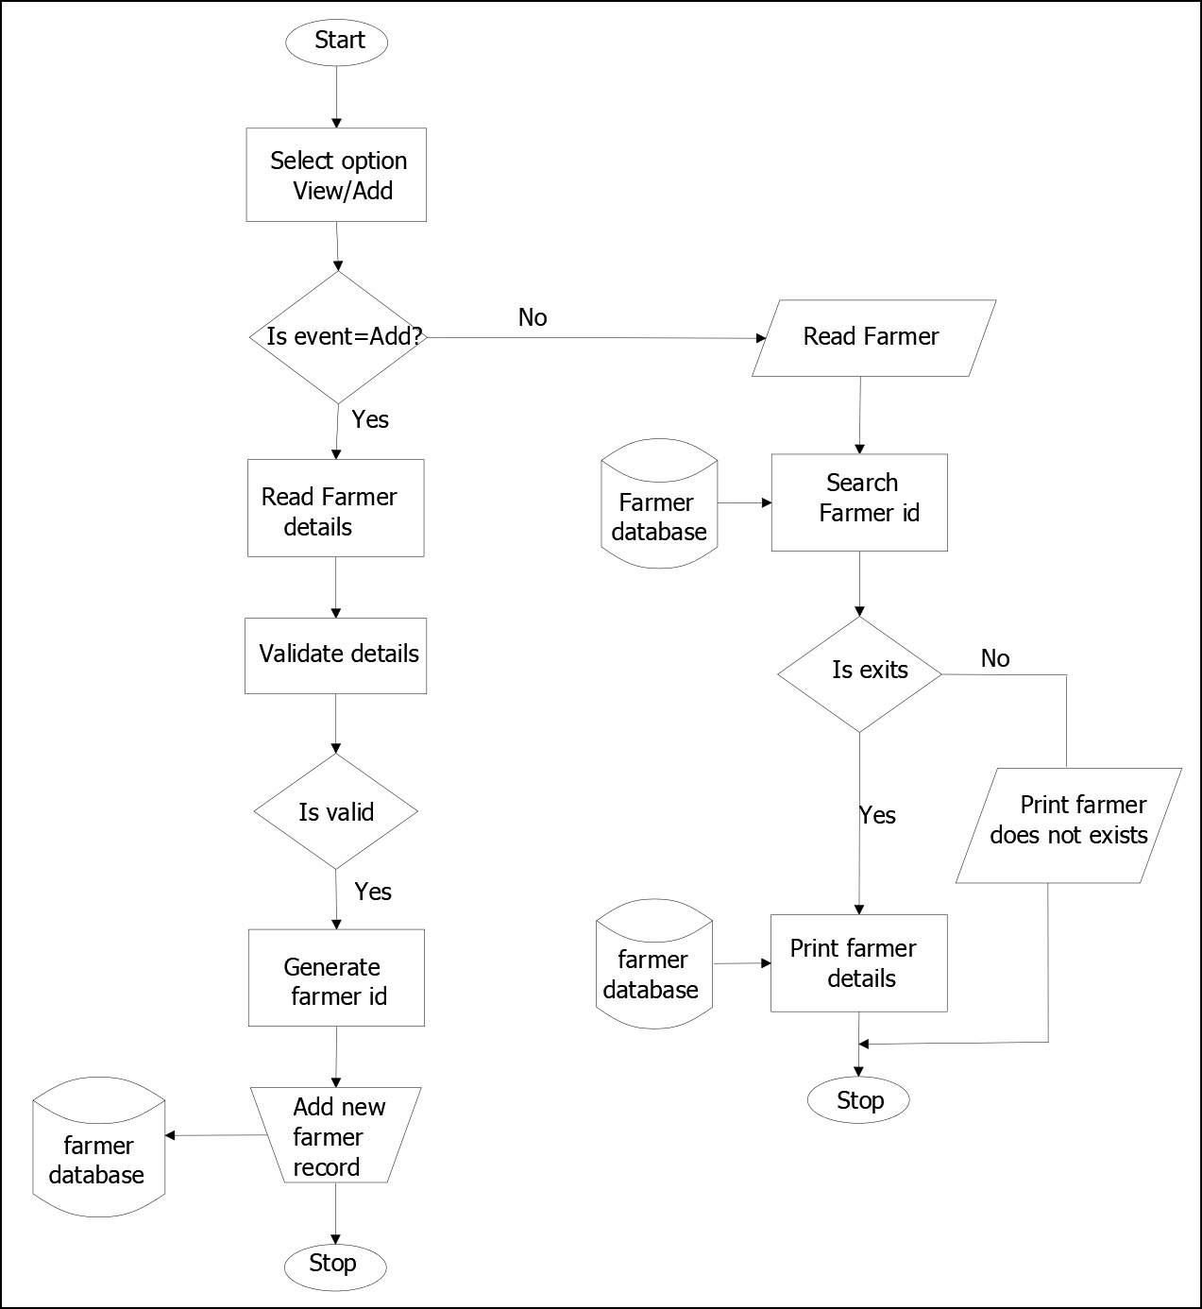
Figure 2.19 flow chart for the Farmer

File I/O interfaces
To input the details of farmer
Outputs: farmer details

Chapter 3
INPUT AND OUTPUT SCREENS
3.1. Introduction
The Web Application “Elight Safari”, is a user-friendly GUI based software which is developed using PHP as frontend tool and MySQL Server as backend. The system was developed such that the user has minimal number of inputs.
The users of this Web Application are Admin, Service Providers and Users. Admin is given complete access to all the functionality of the software.

3.2. Home Page

This is the homepage of Elight Safari; this page will be displayed as soon as the website link is clicked.
Description
This is the screen that appears when the user opens the website. When user clicks on the link the main page is displayed.
Navigation
This page is the main page of Elight Safari.
Elements
Links to different pages.

3.3. Admin Login

This is the admin login page for admin. The admin manages the entire system. By entering the username and password the admin can login to the system.
Description
This is the screen that appears when the admin tries to login to the system. When the admin enters valid username and password, he is allowed to enter the dashboard.
Navigation
This page is located inside admin section. Admin must click to open it.
Elements
Username: Type: textbox, Text: Username Content: Please enter username
Password: Type: password, Text: Password Content: Please enter password
Sign In: Type: button, Text: Submit
Content: it is used to submit the form and check if username and password are valid.

3.4. Admin Login

This is the admin login page for admin. The admin manages the entire system. By entering the username and password the admin can login to the system.
Description
This is the screen that appears when the admin tries to login to the system. When the admin enters valid username and password, he is allowed to enter the dashboard.
Navigation
This page is located inside admin section. Admin must click to open it.
Elements
Username: Type: textbox, Text: Username Content: Please enter username
Password: Type: password, Text: Password Content: Please enter password
Sign In: Type: button, Text: Submit
Content: it is used to submit the form and check if username and password are valid.

3.5. Admin Login

This is the admin login page for admin. The admin manages the entire system. By entering the username and password the admin can login to the system.
Description
This is the screen that appears when the admin tries to login to the system. When the admin enters valid username and password, he is allowed to enter the dashboard.
Navigation
This page is located inside admin section. Admin must click to open it.
Elements
Username: Type: textbox, Text: Username Content: Please enter username
Password: Type: password, Text: Password Content: Please enter password
Sign In: Type: button, Text: Submit
Content: it is used to submit the form and check if username and password are valid.

3.6. Admin Login

This is the admin login page for admin. The admin manages the entire system. By entering the username and password the admin can login to the system.
Description
This is the screen that appears when the admin tries to login to the system. When the admin enters valid username and password, he is allowed to enter the dashboard.
Navigation
This page is located inside admin section. Admin must click to open it.
Elements
Username: Type: textbox, Text: Username Content: Please enter username
Password: Type: password, Text: Password Content: Please enter password
Sign In: Type: button, Text: Submit
Content: it is used to submit the form and check if username and password are valid.

3.7. Admin Login

This is the admin login page for admin. The admin manages the entire system. By entering the username and password the admin can login to the system.
Description
This is the screen that appears when the admin tries to login to the system. When the admin enters valid username and password, he is allowed to enter the dashboard.
Navigation
This page is located inside admin section. Admin must click to open it.
Elements
Username: Type: textbox, Text: Username Content: Please enter username
Password: Type: password, Text: Password Content: Please enter password
Sign In: Type: button, Text: Submit
Content: it is used to submit the form and check if username and password are valid.

3.8. Admin Login

This is the admin login page for admin. The admin manages the entire system. By entering the username and password the admin can login to the system.
Description
This is the screen that appears when the admin tries to login to the system. When the admin enters valid username and password, he is allowed to enter the dashboard.
Navigation
This page is located inside admin section. Admin must click to open it.
Elements
Username: Type: textbox, Text: Username Content: Please enter username
Password: Type: password, Text: Password Content: Please enter password
Sign In: Type: button, Text: Submit
Content: it is used to submit the form and check if username and password are valid.

3.9. Admin Login

This is the admin login page for admin. The admin manages the entire system. By entering the username and password the admin can login to the system.
Description
This is the screen that appears when the admin tries to login to the system. When the admin enters valid username and password, he is allowed to enter the dashboard.
Navigation
This page is located inside admin section. Admin must click to open it.
Elements
Username: Type: textbox, Text: Username Content: Please enter username
Password: Type: password, Text: Password Content: Please enter password
Sign In: Type: button, Text: Submit
Content: it is used to submit the form and check if username and password are valid.

3.10. Admin Login

This is the admin login page for admin. The admin manages the entire system. By entering the username and password the admin can login to the system.
Description
This is the screen that appears when the admin tries to login to the system. When the admin enters valid username and password, he is allowed to enter the dashboard.
Navigation
This page is located inside admin section. Admin must click to open it.
Elements
Username: Type: textbox, Text: Username Content: Please enter username
Password: Type: password, Text: Password Content: Please enter password
Sign In: Type: button, Text: Submit
Content: it is used to submit the form and check if username and password are valid.

3.11. Admin Login

This is the admin login page for admin. The admin manages the entire system. By entering the username and password the admin can login to the system.
Description
This is the screen that appears when the admin tries to login to the system. When the admin enters valid username and password, he is allowed to enter the dashboard.
Navigation
This page is located inside admin section. Admin must click to open it.
Elements
Username: Type: textbox, Text: Username Content: Please enter username
Password: Type: password, Text: Password Content: Please enter password
Sign In: Type: button, Text: Submit
Content: it is used to submit the form and check if username and password are valid.

Chapter 4
Testing

4.1. Introduction
Software testing is an investigation conducted to provide stack holders with information about the quality of the product or service under test. Testing has been defined as the process of analyzing a software item to detect the differences between existing and required conditions and to evaluate the features of the software item. Software testing is the process used to assess the quality of computer software.
It involves the operation of a system or application under controlled conditions and evaluating the results. The conditions controlled should include both normal and abnormal conditions. Testing should intentionally attempt to make things go wrong to determine things happen when they should. It is oriented to ‘detection’.
Software testing has three main purposes:
- The verification process confirms that the software meets its technical specifications. A “specification” is a description of a function in terms of a measurable output value given a specific input value under specific preconditions.
- The validation process confirms that the software meets the business requirements.
- A defect is a variance between the expected and actual result. The defect’s ultimate source may be traced to a fault introduced in the specification, design or development phases. Not all the defects with which necessarily result in failure.
There are two types of software testing:
- Black box testing -internal system design - is not considered in this type of testing. Tests are based on requirements and functionality.
- White box testing-this testing is based on knowledge of the internal logic of an application’s code. Also known as glass box testing. Tests are based on coverage of code statements, branches, paths and conditions.
A test case is a software testing document, which consists of events, actions, input, output, expected result and actual result. Clinically defined a test case is an input and an expected result. This can be pragmatic as x your derived result is y’; whereas other test cases describe in more detail the input scenario and what results might be expected outcome. It can occasionally be a series of steps but one with expected results or expected outcome. A test case should also contain a place for the actual result.
White box testing is applicable at the unit, integration and system levels of software testing process.

4.2. Test Reports
4.2.1. Unit Testing
Unit testing focuses effort on the smallest unit of software design. This is known as module testing. The modules are tested separately. The test is carried out during programming stage itself. In this step, each module is found to be working satisfactory as regards the expected output from the module.

Test cases
4.2.1.1. Admin Login form
Test Scenario ID |  | Login-1 |  | Test Case ID |  |  | Login-1A
Test Description Case |  | Login – successful or not |  | Test Priority |  |  | High
Pre-Requisite |  | A valid user account |  | Post-Requisite |  |  | NA
Test Execution Steps:
S. No | Action | Inputs | Expected  Output | Actual Output | Test  Brows  er | Test  Result | Test  Comments
1 | If user clicks on  login button  without  entering  username  and  password. | Inputs are not.  given | Please  enter  username  and  password | Please  enter  username  and  password | Chrome | Pass | [26/04/2026 11:44 AM]: invalid login attempt
2 | Enter  correct  username  &Password  and hit  login  button | username  test@xyz.com  Password:  ****** | Login  success | Login  success | Chrome | Pass | [26/04/2026 11:44 AM]: Login  successful
3 | If username is blank but password is  entered. | Password:  ****** | Please enter username | Please enter username | Chrome | Pass | [26/04/2026 11:44 AM]: invalid login  attempt
4 | If password is blank but username is  entered. | Username: Mokshith | Please enter password | Please enter password | Chrome | Pass | [26/04/2026 11:44 AM]: invalid login attempt
5 | If the username or  Password is incorrect. | Username: Mokshith Password:  ***** | Invalid login credentials | Invalid login credentials | Chrome | Pass | [26/04/2026 11:44 AM]:  Invalid login attempt

4.2.1.2. User Login form
Test Scenario ID |  | Login-1 |  | Test Case ID |  |  | Login-1A
Test Description Case |  | Login – successful or not |  | Test Priority |  |  | High
Pre-Requisite |  | A valid user account |  | Post-Requisite |  |  | NA
Test Execution Steps:
S. No | Action | Inputs | Expected  Output | Actual Output | Test  Brows  er | Test  Result | Test  Comments
1 | If user  Click on login button without entering username and  password. | Inputs are not given | Please enter username and password | Please enter username and password | Chrome | Pass | [26/04/2026 11:44 AM]:  invalid login attempt
2 | Enter correct username & Password and hit login.  button | username test@xyz.com Password:  ****** | Login success | Login success | Chrome | Pass | [26/04/2026 11:44 AM]:  Login successful
3 | If username is blank but password is  entered. | Password:  ****** | Please enter username | Please enter username | Chrome | Pass | [26/04/2026 11:44 AM]:  Invalid login attempt
4 | If password is blank but username is  entered. | Username: Mathew | Please enter password | Please enter password | Chrome | Pass | [26/04/2026 11:44 AM]:  Invalid login  attempt
5 | If the  username or  password is incorrect. | Username: Komban Password:  ***** | Invalid login credentials | Invalid login credentials | Chrome | Pass | [26/04/2026 11:44 AM]:  invalid login  attempt

4.2.2. Integrate Testing
Data can be lost across an interface. One module can have an adverse effect on another, sub functions, when combined, may not be linked in desired manner in major functions. Integration testing is a systematic approach for constructing the program structure, while at the same time conducting tests to uncover errors associated within the interface. The objective is to take unit tested modules and build program structure. All the modules are combined and tested as a whole.
4.2.3. System Testing
System testing refers to the testing of complete system that is carried out by testers sometimes by the developers to check whether it meets the system specifications or not. System testing involves both functional and non-functional testing. In the system the behavior of whole system product is tested as defined by the scope of the development project. It may include tests based on risks or requirement specification, business process, use cases or other high-level description of the system behavior, interaction with the operating system, and system resources.

SL.NO | Test Condition | Test Result
1 | System Loading | Successful
2 | System Run Procedure | Successful
3 | File I/O Operation | Successful
4 | Database Communication | Successful
5 | Server/Client Interaction | Successful
6 | Memory Usage | Normal
7 | System Processor Usage | Normal
8 | Authentication/Authorization | Successful
9 | Back Up/Recovery | Successful

Chapter 5
CONCLUSION
5.1. Limitations
Elight Safari has some drawbacks that we have observed:
          - Currently it is only a web application, it is not available as an android or iOS application.
          - The application now runs only in local system.
          - The application is currently used with the few modules.
          - The backend storage is limited.
5.2. Scope for Enhancement (Future scope)
- More modules can be added.
- Application can be hosted in server.
- In future, this web application could be integrated with the android and iOS applications.
5.3. Conclusion
The Elight Safari project is a tourism-based project. The project mainly consists of three modules, admin, service provider, and client. Admin adds the tourism places to the website and manages the places which also consist of Google maps of the added places. Clients, who are the end users of the project, register to the website and view the tourist places and also view the directions to the places with the help of Google map. The project also helps the clients by providing information about the special food items in that particular tourist place. The service provider provides the listed food services to the client in that specific tourist place.
5.4. Abbreviation and Acronyms (Lists)
I/O: Input/Output
OS: Operating System DFD: Data Flow Diagram ADMIN: The Administrator
CFD: Context Flow Diagram
RDBMS: Relational Database Management System
RAM: Random Access Memory
SQL: Structured Query Language
SRS: Software Requirement Specification
IIS: Internet Information Server HTML5: Hyper Text Markup Language5 CSS: Cascading Style Sheet
ER Diagram: Entity Relationship Diagram
1NF: First Normal Form 2NF: Second Normal Form 3NF: Third Normal Form PK: Primary Key
FK: Foreign Key
DBMS: Database Management System

5.5. Bibliography/ References (list in specified format)
- https://www.tutorialspoint.com/php/index.htm
- https://javascript.info/
- https://www.tutorialspoint.com/javascript/index.htm
- https://www.codecademy.com/learn/introduction-to-javascript
- Learning PHP, MySQL, JavaScript, CSS, and HTML5: A Step-by-Step Guide to Creating Dynamic Website by Robin Nixon (Author)
- PANKAJ JALOTE’s SOFTWARE ENGINEERING: A PRECISE APPROACH by Pankaj Jalote (Author)

